**[Rum Punch](https://www.tasteatlas.com/rum-punch" \t "_blank)**

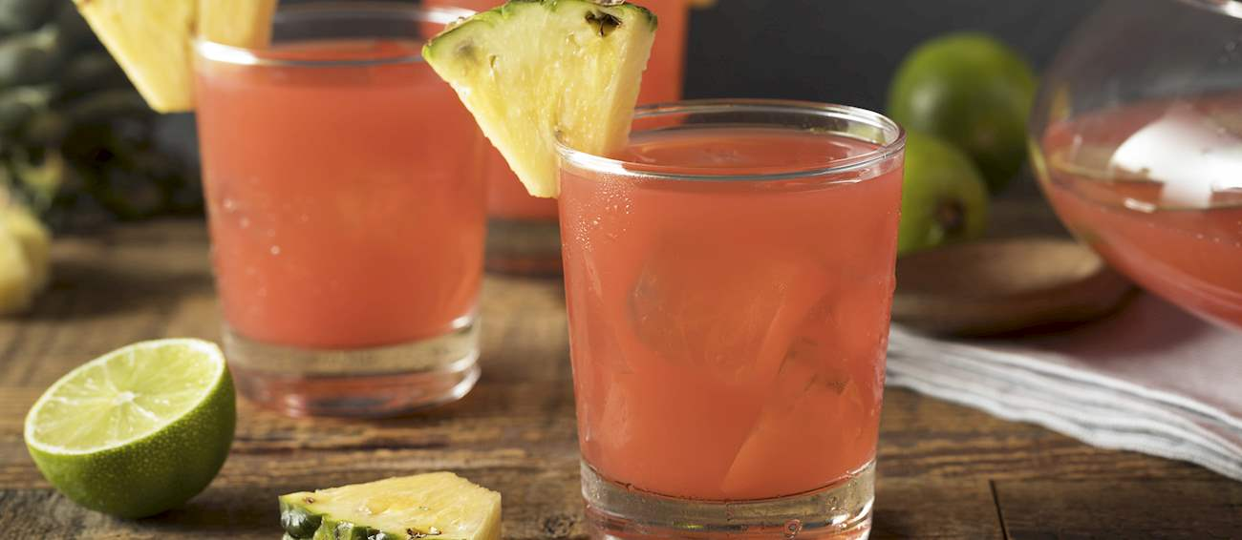

*Rum Punch* is a classic Caribbean cocktail made with rum, fruit juice, sugar syrup, and water. To prepare it, all you need to do is remember this Caribbean saying: “One of sour, two of sweet, three of strong, and four of weak.” A shot of fruit juice, two shots of sugar syrup, three shots of rum, and four shots of water are combined in a big glass or a jug, then poured into a glass over ice.

It is recommended to add a few drops of bitters or some freshly grated nutmeg to elevate the flavors even further. Garnish it with a pineapple wedge for the best possible experience.